If source servlet comp and dest web comp are there in the same web application

Then

* Request attributes( if source servlet comp and dest web comp are using same req,res objs)
* Session Attributes(if source servlet comp and dest web comp are getting request from same browser s/w of client machine).
* Application Attributes( if source servlet comp and dest web comp are not using same req,res objs and not getting request from same browser software.

The attribute is a name that holds obj as value having scope like

* Request scope🡪 specific to each request.
* Session scope 🡪 specific to each browser s/w of client machine.
* Application scope 🡪 specific to each web application.

Use Cases of Attributes:

=================

* In layered App, if servlet comp generates results/gather results and passes the result to view comp(JSP) by keeping the results in request scope.
* The login credentials like username,password will be placed in session scope because login activity is always specific to browser software of client machine.
* The global arithmetic and logical operations with respect to all web comp like request count should be taken as the servletcontext attributes.

If source servlet comp and dest web comp are there in the diff web applications of same server or different servers

Then

* Append the query string to url of res.sendRedirect(-) method.



1.Request Attributes:

=============

* Memory is allocated to request attributes in request object.
* This variable have request scope. i.e request scope data can be accessed in all web comps that are using same request object while processing a request.

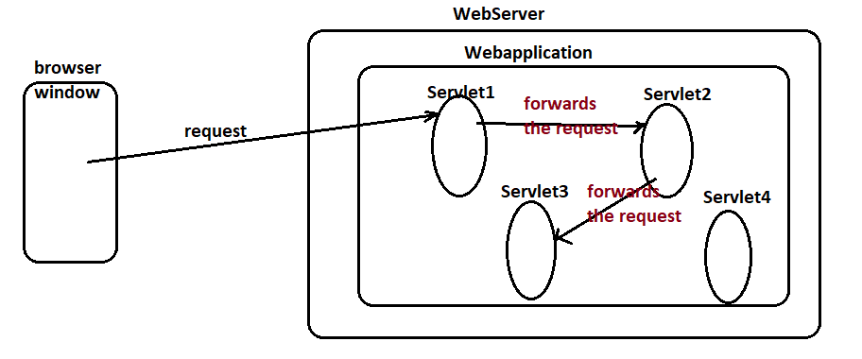

The request attribute created in servlet1 is visible and accessible in servelt2,servlet3 while processing the request given to servlet1 but not in servlet4 because servlet1,servlet2,servlet3 comps are going to use same req,res objects while processing the request given to servlet1 comp.

Creating Request Attributes:

====================

Req.setAttribute(“attr1”,val-1);

This method is multi-purpose method i.e it creates the attribute in the object/scope if the attribute is not already there otherwise it modifies the existing attribute value.

To read request attribute values

======================



To remove request Attributes

====================



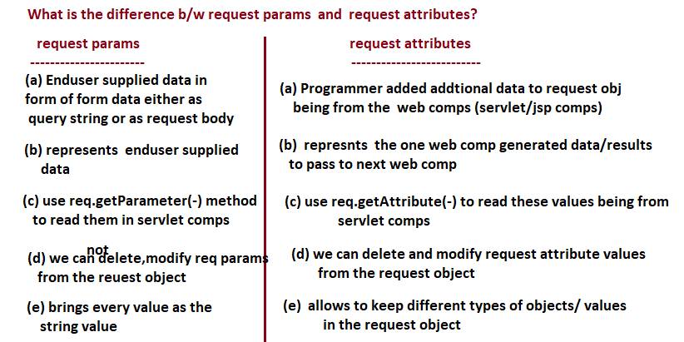

**Example:**

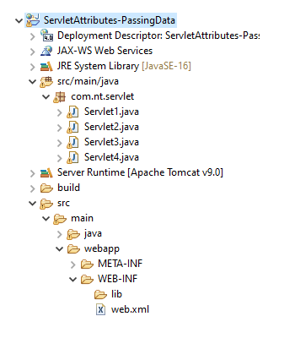

**Servlet1.java**

**------------------**

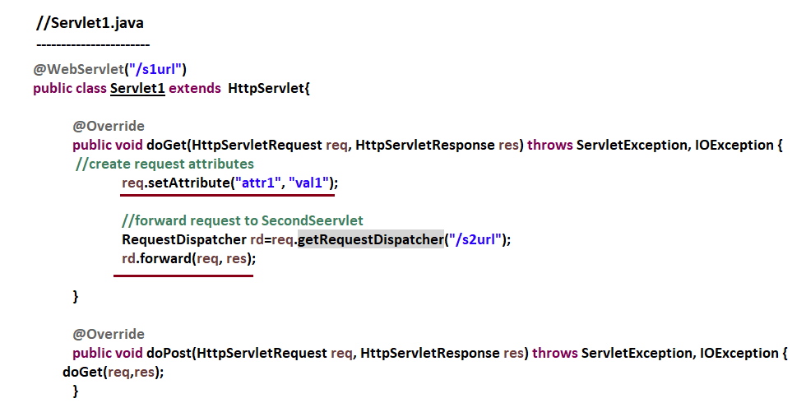

Servlet2.java

=========

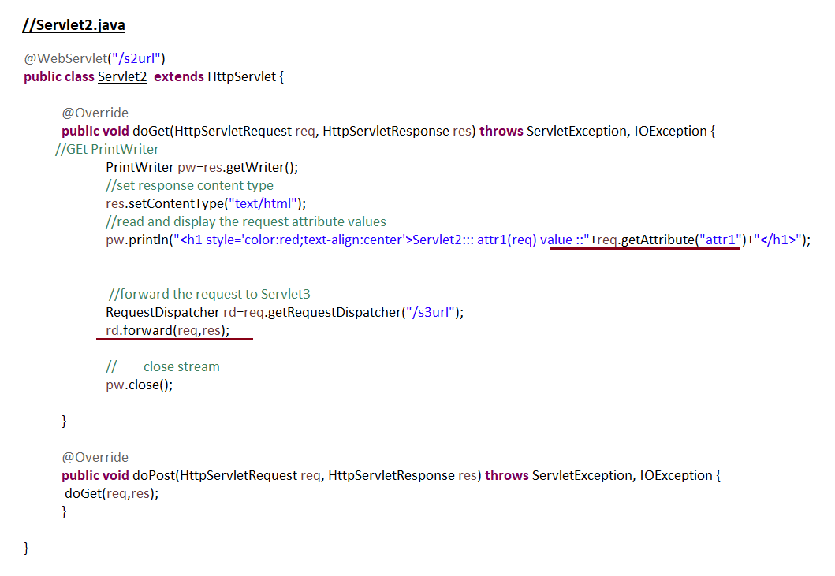

Servlet3.java

==========

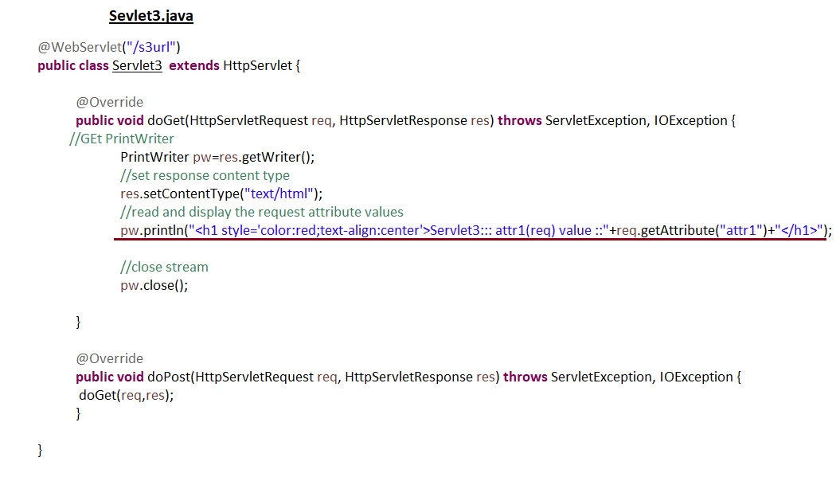

Setvlet4.java

==========

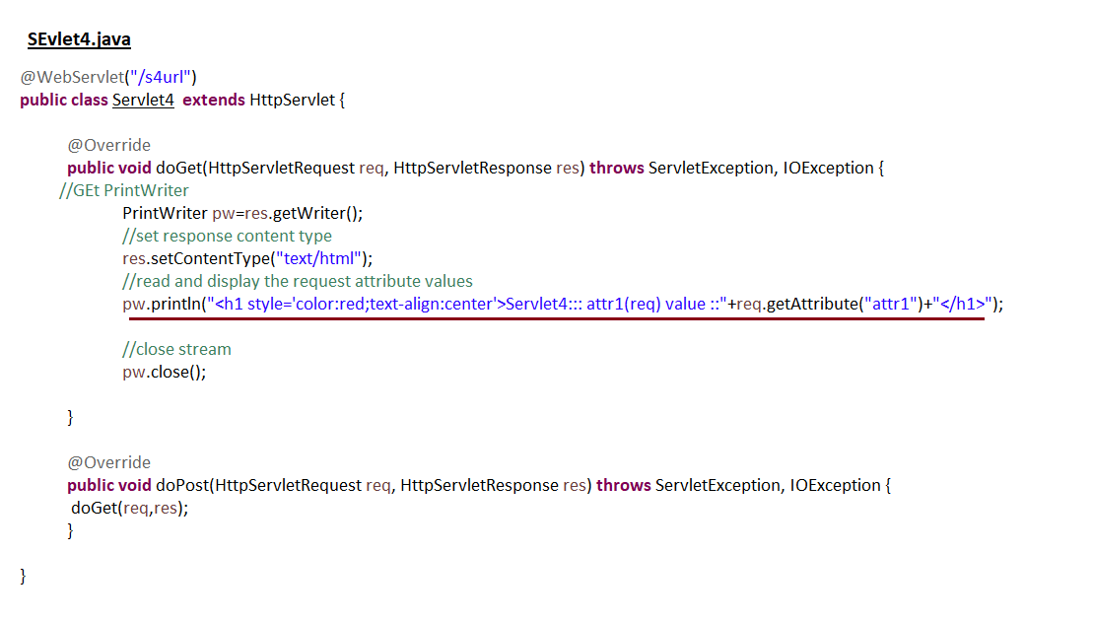

Output:

=======

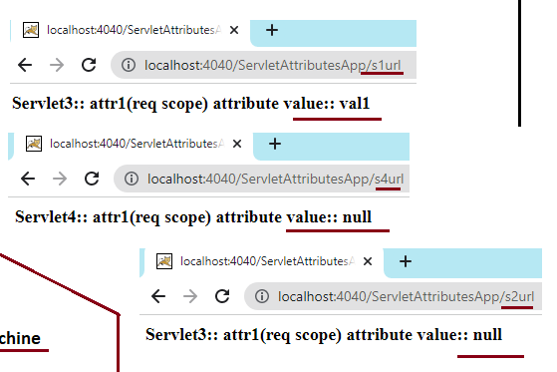

**2. Session Attributes**

**================**

* Allocates memory in Session/HttpSession object.
* The Session/HttpSession obj and its session attributes are visible and accessible in all web comps of web application irrespective the req,res objects they are using but they must get request from same browser for “whom session object and its attributes are created”.
* Session attributes scope is session scope i.e they are very much specific to browser s/w of client machine.

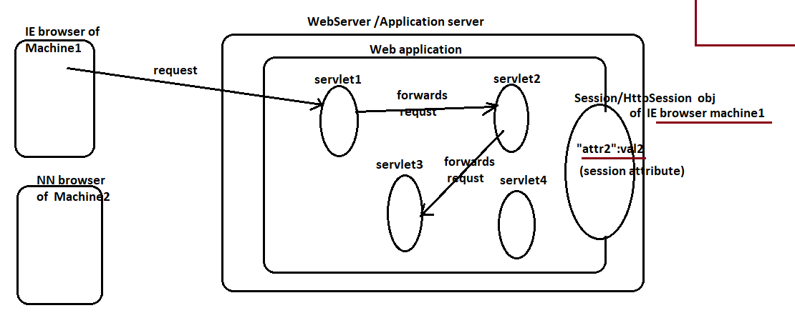

The session attribute created in servlet1 comp by getting request from IE browser of machine1 is visible and accessible in all otherweb comps of web application only when they request from IE browser of machine1.

To create Session Attribute

==================



To modify Session attribute

====================



To read session attribute value

=====================



Note:- tabs and windows of browser s/w in the client machine will not be treated as separate clients.. they are part of browser s/w as client.

3. ServletContext attributes/application attributes:

==================================

* These attributes allocate memory in servletContext object and known as gloabal attributes because attributes are visible and accessible in all web comps of web application irrespective of req,res objs they are using and the browser s/w from which they are getting request.
* Since servletcontext obj is global memory of web application, so the servlet context attributes are called global attributes of web application.

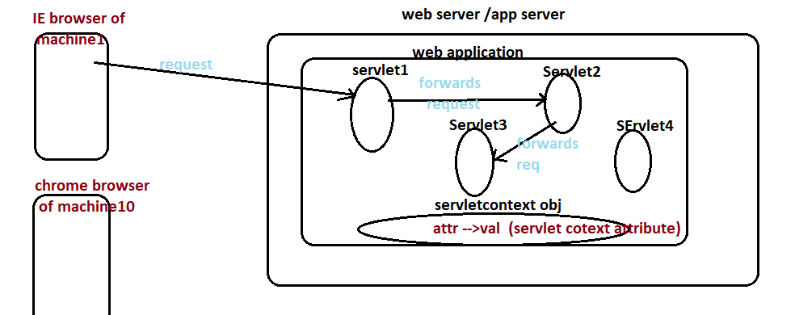

The servlet context attributes created in servlet1 comp by getting request from any browser is visible and accessible in all web comps of web application irrespective of any condition i.3 irrespective of req,res objs they are using and irrespective of browser window from which they are request(application scope).

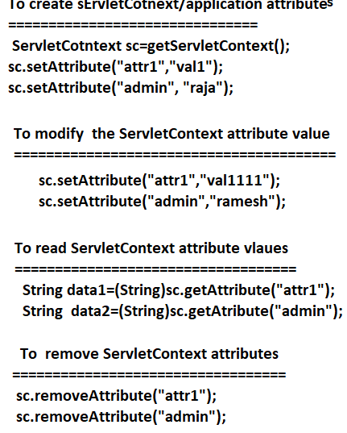

**Example:**

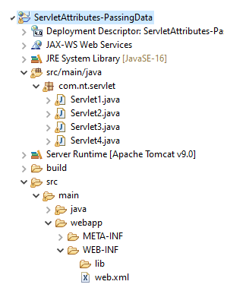

Servlet1.java

-----------------

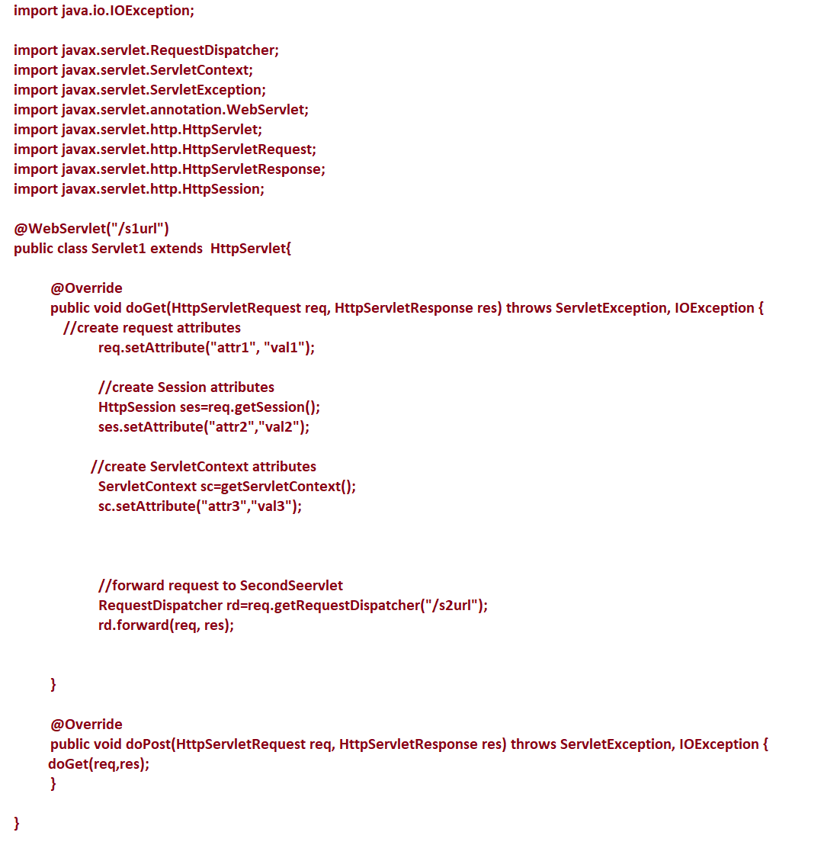

Servlet2.java

----------------

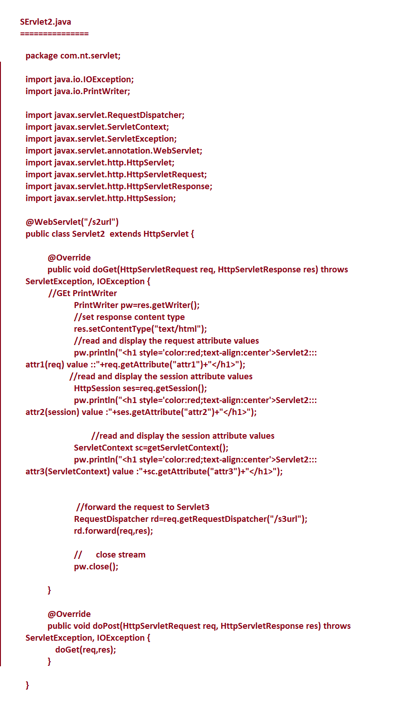

Servlet3.java

----------------

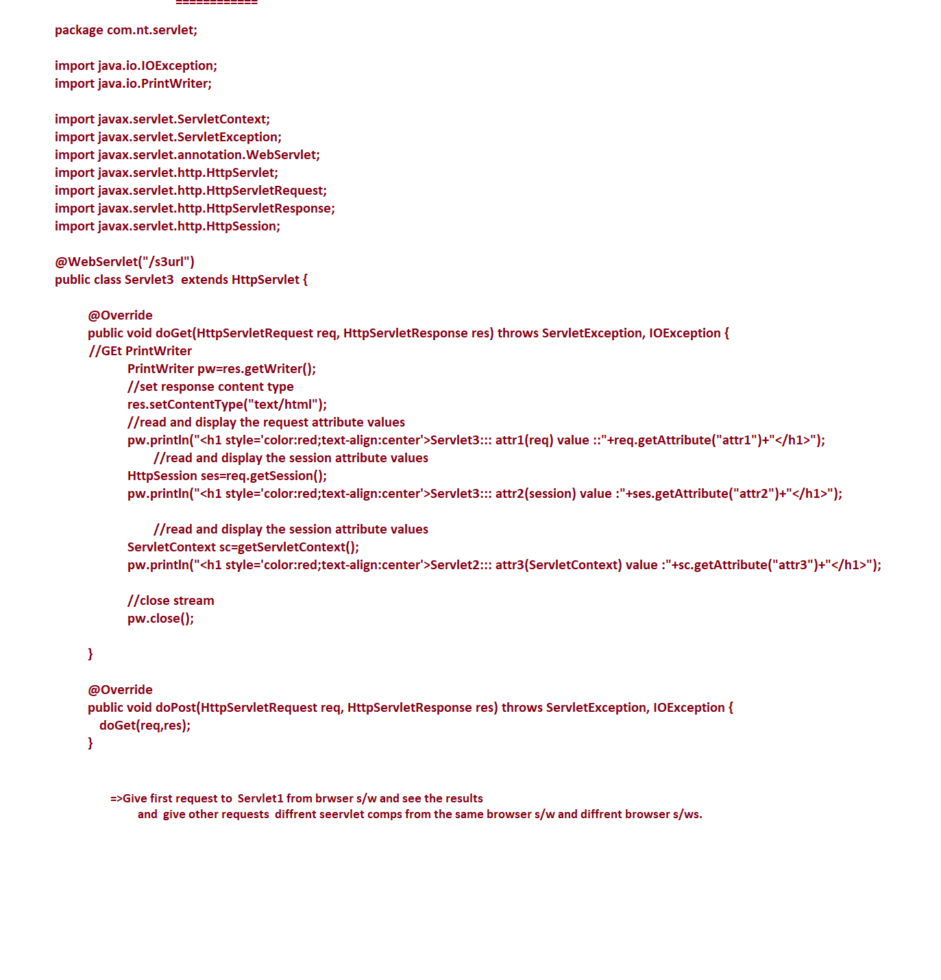

Servlet4.java

----------------

